I swore I'd never be there, but my baby's birth was mesmerising
By TOM SYKES - More by this author » Last updated at 13:36pm on 29th November 2007
Comments
A few months ago I wrote in this newspaper that I had no intention of being present at the birth of my second child. The whole business of childbirth, I wrote, was messy, alarming, puts men off sex and was not something that I wished to witness again.
And what use would a husband be in the delivery suite anyway?
Well, that noise you can hear is the sound of a man earnestly munching his way through a giant-sized portion of humble pie, because my wife Sasha has just given birth to a perfect baby girl - and I was there.
Scroll down for more...
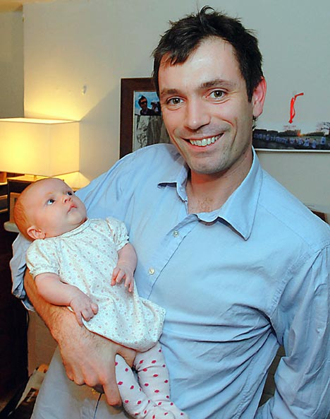
Hand on: Tom Sykes with his daughter Eleanor
And I'm told I was more than a little bit useful as well.
So what happened to my conviction that I'd rather stick red-hot pins in my flesh than be in the delivery room? Well, in the course of my research, I spoke to a number of birthing gurus, including Marie Mongan, the American creator of a program called HypnoBirthing that is sweeping through fashionable society moms in the United States faster than a Californian wildfire. It was a conversation that didn't turn out too well.
You see, Ms Mongan and I disagreed on the role of the father in the birth of his offspring - somewhat violently. I tended towards the school of thought that the father should be down the pub awaiting the good news. Ms Mongan, by contrast, insisted that "men do feel wonderful" being present at the birth, and that being on hand is, "part of completing what you started as a couple" and that my prespositionedence was necessary to pass on the right "energy" to the child.
My reaction? I wrote, "Frankly, most men I know consider such psychobabble a load of old cobblers." While some individuals find words like "healing", "chakra" and "energy" soothing, they actually make me angry, and HypnoBirthing sounded like exactly the sort of hippy-dippy, New Age nonsense that I abhor. But then came a strange coincidence.
Two couples told us that they had used HypnoBirthing, and credited the program with the easy births they had experienced. Sasha wanted to give the system a try. When faced with a choice between his principles and the wishes of his pregnant wife, a wise man will abandon his principles in a flash.
And so, I somehow found myself lying back in a remarkably comfortable, reclining armchair, being gently lulled into a trance by hypnotherapist Aisling Killoran, who runs the Dublin clinic Accomplish Change. In a lilting, mellifluous voice, Aisling began to intone affirmations about how easy and natural the birth would be into our ears. "My baby is perfectly for an easy and comfortable-birth," she chanted, "I am relaxed and happy that my baby is finally coming to me."
Despite all my deep-seated hostility to alternative healing methods, I went under like a light. One moment I was thinking, "I can't believe I am listening to this tripe," and the next Aisling was summoning us both back to consciousness by counting down from five to one. I felt incredibly refreshed when I came round, and it was at this point that Aisling delivered the bombshell; during labour, I had to be in the room for Hypno-Birthing to work. My job was to repeat the affirmations and massage Sasha's arm and back to trigger a relaxed, fear-free state that would make it easy for the baby to emerge.
Over the next few weeks we listened to Aisling on repeat on the CD player, and I even read up all about the system in Ms Mongan's book, HypnoBirthing. Maybe something had been planted in my brain by the hypnosis but the more I read, the more I began to appreciate her alternative approach to birthing. Her theory is that in many non-Western cultures giving birth is not something that is feared and, because it is generally assumed that everything will turn out OK, women are a lot more relaxed and give birth more easily. But in our society, women have learned to fear birth, says Mongan. Pick up almost any modern pregnancy book, and it's hard to disagree.
As a result of that fear, when the time comes to give birth, there is a flood of adrenaline coursing around the body of the average labouring mother, and the whole affair becomes incredibly fraught. Techniques like self-hypnosis and guided meditation aim to reduce this fear, and affirmations serve to reprogram the mind. In essence, HypnoBirthing says that instead of thinking about all the stuff that might go wrong, why not see it all going right? Why not indeed, I thought, as my credentials as a sceptic disappeared out of the window. And if it all turns out to be a load of nonsense, well, at least it's harmless, and Sasha can still opt to be hooked up to an epidural.
Then, one Tuesday night, around 11pm, something started to happen. In the few short minutes it took to throw a nightdress and some other essentials into a bag, we were gunning at top speed through the inky blackness towards the hospital. As the surges (the touchy-feely HypnoBirthing word for contractions) started coming - eight minutes apart, then seven, then six - I felt increasingly helpless.
And then I thought, well, what the hell, it might just help, and I told Sasha to close her eyes and concentrate on my voice. "I meet each surge with confidence and joy," I found myself saying, "I am happy and excited my baby is finally coming to me." Sasha let out a deep breath. I felt ridiculous but I carried on, suddenly understanding why people say there are no atheists on a plane which is crashing. "My baby is perfectly positioned for an easy, comfortable, birth," I said, in measured tones, consciously imitating Aisling's singsong delivery on the CD, "I turn my birthing over to nature. My body knows what to do." "It's helping," said Sasha, "I just had another one and it didn't hurt as much."
By the time we arrived at the hospital, we were totally chilled out. We sat in the car park for another ten minutes while I took Sasha on a guided meditation around the woods she used to play in as a child - the "safe place" that we had identified with Aisling as a relaxing location for Sasha's mind to go to at the crucial moments. It felt oddly cosy - almost magical - in our old Citroen, but we couldn't stay in the car park all night. So in we went, to the bright lights of the hospital.
As we made our way up to the maternity department, Sasha continued to use the self-hypnosis and meditation techniques and stayed incredibly calm and relaxed. It was all very different to last time when Sasha was wailing in agony on the street in New York where we were then living as we tried to hail a taxi. A few minutes later her waters broke, and we were rapidly moved into the delivery room as the birth began in earnest. For all her calmness previously, Sasha screamed the hospital down for the few minutes when she was pushing the baby out, but it all happened so fast that there was no time for her to be given an epidural, or any other chemical pain relief except puffing on gas and air.
Instead, the poor girl had to make do with her crazy husband mumbling in her ear, "Breathe in the green! Feel the colour flowing through your whole body! You are more relaxed than you ever thought possible!" But then, very quickly, the baby was out, and she let out her first little cries of life.
We had signed into the hospital at 12:15am and baby Eleanor was born one hour and 19 minutes later. Being wrong rarely feels this good.

