Hypnobirthing: A man taking charge during childbirth?

I was a bit skeptical about hypnobirthing too, but there really is a way for men to take some of the strain on the big day.
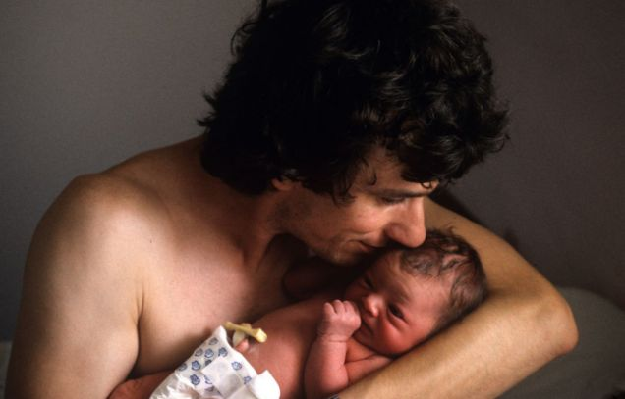
Hypnobirthing can ease the trauma of childbirth for everyone
I had always believed the maternity ward delivery room was a woman’s domain. That the man’s role consisted of calling for the ambulance or rushing his partner to hospital, then waiting nervously in the hospital corridor praying for everything to be OK and over as quickly as possible. Or maybe, if my presence was absolutely demanded, stealing a drag on the laughing gas and saying patronising things such as ‘keep going, darling’.
So I prepared to be of limited use to my wife Candy: I would hold her trembling hand while absorbing her abuse. Until that is, I reluctantly agreed to miss football and spend two whole Saturdays on a hypnobirthing course.
I had no idea the man could play such a leading role in childbirth. But when, erm, push came to shove, there I was, relaxing my wife, focusing her breathing, working through the birth plan with the midwives and making informed decisions with confidence. I amazed myself. In my wife’s words, after the safe arrival of our baby Jude: ‘I was the body, you were the mind.’
Giving birth is the most natural thing a woman can do, yet many female minds are filled with horror stories. Fear leads to tension, which can restrict the body at a time when it needs to let nature take its course. Hypnobirthing offers hypnosis in labour and childbirth to women who want to be in control of a drug-free, comfortable delivery and get their men pulling their weight.
Now more popular than ever in Britain, hypnobirthing is a complete antenatal education for whatever kind of birth you’re planning. We chose a hospital birth pool – alternative, yes, but perfectly normal in the modern age; even old-school midwives are coming round to it.
Signing up to Berkshire HypnoBirthing, we joined three other couples eight weeks before their due date at a Pilates studio in Reading. The comprehensive course was split over two days and our hypnoteacher, Vanessa Turner, made learning each new topic easy, between lessons sending the group into a state of deep relaxation.
‘HypnoBirthing techniques and methods are easy to learn and apply,’ says Turner (inset left). ‘They play a vital role in making the birthing experience calmer, more peaceful and meaningful for mum, dad and baby.
‘The man’s role is crucial. He provides practical, emotional and physical support – much better than sitting in the corner wondering what he can do to help.’
Turner explained ten ways to achieve a gentle birth, the rationale for hypnosis in birth and how to block out birth nightmares. We were told to not even consider them and to leave out negative energy. The mind can only hold one thought at a time and the course places great importance on desire, belief, relaxation and visualisation.
Turner explained how thought precedes reality and how every emotion triggers a physical response. A section was devoted to big babies, a common fear, and the women were made to trust their inner knowledge or instinct, to trust that their body knows exactly what to do.
The group was then shown images illustrating the various stages of birth and a selection of calming hypnobirths on DVD. The men were in charge of relaxation-deepening exercises, helping dump negative energy and thoughts.
‘I teach a wide variety of techniques and encourage men to become fully involved,’ says Turner. ‘It builds their confidence, helps them trust themselves and means they can learn what a woman needs at different stages of labour and birth.’
During the breathing exercises I spoke in a slow, calming voice to enhance a trance-like sensation, the idea being to maintain focus and reduce discomfort. Hypnobirthing bans words such as ‘pain’ and ‘contractions’ as these are considered negative –‘discomfort’ and ‘surges’ are preferred.
‘The benefits to mum are such that a woman can feel safer, can trust and let go during the process of giving birth more instinctively when she knows her partner is taking care of everything on the outside,’ adds Turner.
‘This means birthing can be a calmer and more comfortable experience where both mum and dad feel confident and in control to make whatever choices are necessary for a healthy delivery of their baby.’
The main goal of the course is to arm prospective parents with the tools to stay in control. It doesn’t end in the classroom, either. We were told to practise the techniques for at least five minutes every day and encouraged to have conversations with the unborn baby and play him music.
I saw my job as learning the birth plan by heart before the contractions – sorry, surges – took hold, to avoid unnecessary medical intervention on the big day.
I was pumped up and ready, and not at all nervous. Two days after her due date and it was action stations – but only my wife can tell you how it went…
For more on hypnobirthing visit www.hypnobirthing.co.uk.

