Follow Jessica Alba’s advise on “Hypnobirthing”
By Rachelle
Posted on 22 May 2011 at 7:37am
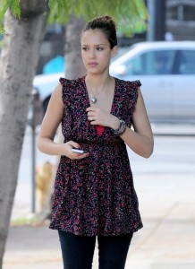
Being a mother is not easy especially during pregnancy and giving birth. But Hollywood mom Jessica Alba knows a great way to ease pain during childbirth. Try “Hypnobirthing”.
Alba revealed her plan during her guesting at the Ellen De Generes show. “What is this that I heard, you’re going to be hypnotized when you give birth?” Ellen asked Jessica on The Ellen DeGeneres Show
“No, no,” Jessica said. “It’s called HypnoBirthing. So it’s not like the clock in front of your face and you go out and you wake up and you got a baby.”
“Wouldn’t that be great? Sign me up. No, it’s basically: my husband takes me through sort of a meditation,” she explained. “So he’s saying, ‘You’re relaxed and you’re floating on clouds,’ while you’re going through labor and your contractions. He just sort of does a guided meditation. I’m just concentrating on breathing and staying relaxed because it’s when you get tense that makes the whole labor worse and more painful.”


Hypnobirthing is getting popular. Everyone’s heard of the Lamaze and Bradley methods of childbirth, but hypnobirthing is a new way to manage pain during delivery. Women across the country are trying it. Also known as the Mongan Method, it involves daydreaming or focusing on visualizations with a birth partner. About 72 percent of moms who employ hypnobirthing do not take pain medication while giving birth. There are scores of hypnobirthing classes, books, DVDs and CDs include exercises to prep the body physically — lots of squatting and breathing — and some cool partner-exercises .
Some celebrities who used this method and swear by it are Tiffani Thiessen from Saved by the Bell and Cougartown‘s Busy Phillips who went the hypnobirthing route with daughter Birdie, born in the summer of 2008.
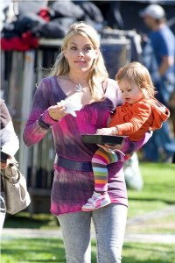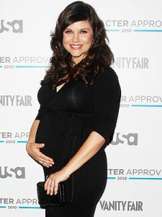

Jessica said she used the same method when she gave birth with her first child. “I actually did this with Honor… It is kind of a way to relax and know that the contraction will only last for so long. You just need to concentrate on the breathing and just the sound of his voice… Normally I want to strangle him but at that moment it’s sort of calming and wonderful.”
Ellen also guessed that Alba’s second child will be a boy. Is Jessica’s second pregnancy easier? “Oh yeah! But a little bit harder on the body because my daughter still wants to be picked up. Ever since my belly popped, she really is on me!” But the Fantastic Four star is not as stressed out about her as she was on her first.
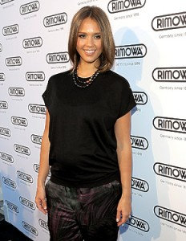
Aside from waiting for her due date, Alba is also working as the creative director of HopScout, an online sale site that offers parents daily blogs and information about kids products.
“I think the coolest part so far is I know as a mom how difficult it is to try and balance work and being a mom. We gave an opportunity to stay-at-home parents to completely work from home,” she explains, adding that in addition to their hourly salary, the company provides their parent bloggers with a computer, as well as money for groceries and their child’s tuition

